COURSE CODE: PRAC101 Section: BSIT - 41013

COURSE TITLE: OJT / PRACTICUM 1

TERM: 1st Semester, SY 2024-2025

PROFESSOR: MR. VINCENT CARLO T. GARADOS

NAME OF STUDENT: Bisnar, Christian Jay A.

**OJT NARRATIVE REPORT**

1. TOPIC: FAMILIARIZING WITH AI SESSION 2: AI TOOLS, TECHNOLOGIES, AND HOW TO LEVERAGE THEM
2. SPEAKER: MR. MARC TONIDO
3. DURATION: 2:30 PM – 3:30 PM
4. SCREENSHOT OF DUTY

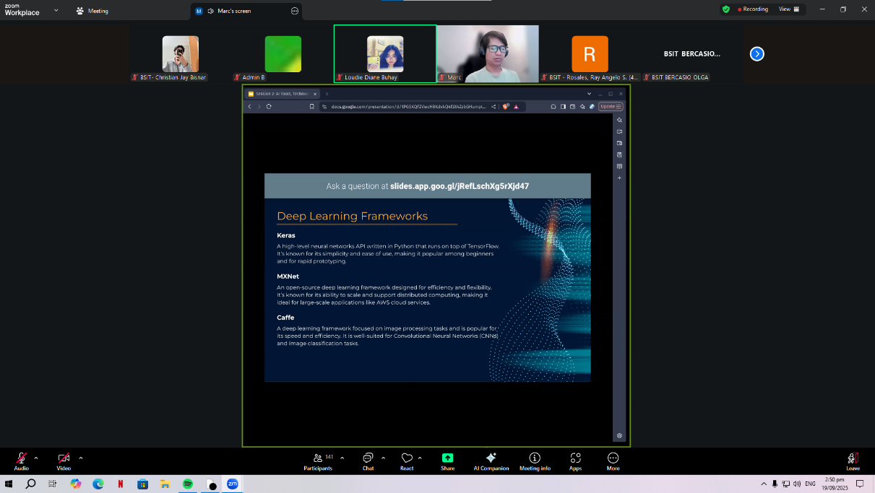

1. REFLECTION

During the session, I gained valuable insights into Deep Learning Frameworks and the process of Building Models from Scratch. The discussion on frameworks such as Keras, MXNet, and Caffe highlighted how these tools make it easier to develop and experiment with AI models. I realized that frameworks not only simplify the coding process but also allow for scalability, flexibility, and efficiency, making them essential for both beginners and professionals in AI development.

The part about Building Models from Scratch was particularly thought-provoking. It emphasized that while creating models from the ground up allows for customization, innovation, and freedom from pre-existing bias, it also comes with challenges such as high data requirements, computational cost, time consumption, and the need for expertise. This made me reflect on the balance between convenience and control—sometimes it is practical to use existing frameworks, but in other cases, building from scratch can lead to breakthroughs in solving specific problems.

Overall, the session deepened my appreciation of AI development. I understood that mastering tools and frameworks is important, but so is recognizing the challenges behind them. This knowledge inspires me to keep learning, especially in understanding when to use existing solutions and when to innovate independently.

What struck me most was how these two approaches—using frameworks versus building from scratch—mirror real-life decision-making. In many cases, we rely on existing tools and systems to save time and resources, but there are also moments when innovation requires us to start from nothing, to create something truly new. This reflection reminded me that as a future professional in the tech field, I must learn to adapt, evaluate situations critically, and choose the right approach depending on the problem at hand.

Overall, this session not only expanded my technical knowledge but also encouraged me to think more deeply about the philosophy and strategy behind AI development. I came to realize that mastering AI is not just about coding or understanding algorithms—it's about balancing efficiency with creativity, leveraging existing resources while not being afraid to innovate, and most importantly, keeping in mind the ethical and practical implications of the solutions we build. This has motivated me to continue learning, to strengthen my technical skills, and to cultivate the critical mindset needed to navigate the evolving landscape of artificial intelligence.